5321 Homework 1

Summer 2020

Guidance for all problems:

1. Develop the minimum set of test cases needed to adequately test all actions and boundary values.
2. List all inputs and expected outputs using the test case table depicted in the previous HW 1 solution. Only show essential inputs and outputs - do not show intermediate values in your test case tables.
3. Develop the test needed for all partitions with two test cases per partition.
4. Assume that currency is truncated to the cent.
5. State any assumptions made, but do not change the function of the problem.
6. Values shown must have thousands separators and reflect the units being depicted. Significance shown must reflect the units being depicted.

The following are customer descriptions of software scenarios. For each problem state any assumptions made - but **do** **not** **change** the function being described.

1) Arlington Amaxon, a retail giant, charges shipping as follows. If the purchase price before tax is below $100 - shipping is a flat $15.95, otherwise if below $300 - shipping is $12.95, otherwise if at or below $500 shipping is $10.95, otherwise if below $750 shipping is a flat $6.95 and otherwise shipping is free. The software calculates the total payment which includes to be purchase price + shipping + tax. Tax is 8.5% of the purchase price. The software has purchase price before tax as an input and returns the total price.

Create the following test case table in Excel.



2) Amaxon, from problem 1, has utilized new software that calculates the shipping as above but on purchase price including tax. The software still uses purchase price before tax as an input and returns the total price. Re-develop the test cases with this in mind.

Create the following test case table in Excel.



3) The Mars simulator is a training device that works as follows. It has 5 retro-braking motor programs RB1-RB5 that are based on altitude above ground level (AGL). It also controls a re-entry chute, extends pod legs and sounds an alarm to prepare for landing. At 5,000 feet AGL RB1 is started, at 4,000 feet AGL RB1 transitions to RB2, at 3,250 feet AGL RB2 transitions to RB3, at 2,750 feet AGL RB3 transitions to RB4, at 900 feet AGL RB4 transitions to RB5, and at touchdown it turns the motor off (OFF). The re-entry chute is deployed at 8,000 feet AGL and is released just above 5,000 feet AGL. Pod legs are extended at 500 feet AGL. The alarm sounds below 350 feet AGL.

For the purposes of defining test cases use the following definitions:

motor states = {RB1, RB2, RB3, RB4, RB5, OFF}

chute = {off,deployed, released}

pod legs = {extend, retract}

alarm = {ON,OFF}

assume that AGL is significant to 0.1 feet. The software method receives AGL as an input and sets the above indicators. For chute, pod legs, and alarm the last value repeats unless the calculated value causes a change.

Use the following in Excel as your test case table.



4) Convert the first three HW problems into decision tables using M03 slide 61 as a guide. Divide this problem into parts a) b) and c) for problem 1-3 respectively. For each, provide

1. the decision table
2. the number of test cases required (do not supply the specific test cases)
3. does this number agree with the number of tests developed above? Yes or No. If no, why not?

5) Arlington Sports Company has developed nice binoculars that are software controlled. 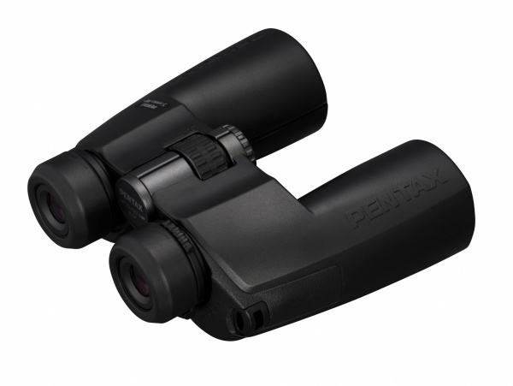

**You may draw the state chart by hand and scan it in please - see the homework submission criteria for information.**

The software works as follows. It starts in the OFF (actually low power) state. When the P button is depressed the binoculars go into the U normal use mode (1X viewing mode) by setting X=1 . When the Z button is depressed in the normal mode the binoculars go to the X5 mode (5X viewing mode) by setting X=2. When the Z button is depressed in the X5 mode the binoculars go into the X10 mode (10X viewing mode) by setting X=3. When in the X10 mode the Z button is depressed the binoculars go into the normal mode by setting X=1.

The binoculars also have a night vision capability. When in the X5 mode if the D button is depressed the binoculars go into the N mode (night vision mode) by setting I=1 (I is infra-red). When in night vision mode if the D button is depressed, the binoculars go back into the X5 mode by setting I=0. No other mode is allowed to use night vision as only the X5 mode is optimized for it.

The binoculars are powered off (OFF) by setting B=0 when in the normal mode and the P button is depressed. B=1 in all other states to turn the battery power on.

The binoculars also have one other very nice feature for the sports enthusiast. It has a built-in GPS receiver that sends its location - this function is performed in hardware. When in the OFF mode, if the software receives a G signal from the GPS receiver it awakes the software and goes into the L mode (locate mode) sending its location via a transponder by setting T=1. This (setting T=1) is only done when in the L mode. When in the L mode pressing the button P will cause the binoculars to go to the OFF mode by setting T=0 and B=0.

When an output is not set to an active value (e.g. I=1) it must be set to 0 (e.g. I=0) by the software. This is true for all outputs.

Draw the simplest state diagram (Mealy). The state diagram may be hand drawn and a picture submitted, BUT the submitted picture must be readable.

Rules:

1. You need to submit the state diagram only.
2. State diagram
   1. Make sure to show the Start input on your diagram as "Start/B=0,I=0,T=0,X=0". This shows us in what state the state machine starts.
   2. Inputs
      1. Label each input as the single letter mnemonic given in the description above.
      2. Inputs cannot occur simultaneously.
      3. Do not depict false inputs on your diagram (e.g., P=F or !P) only show positive events (P)
      4. If two inputs (D, G) can cause the same transition label this as "D, G" not as

"D + G"

* + 1. Make sure that each state completely specifies each input
  1. Outputs
     1. depict all outputs for each transition on the diagram
     2. Depict outputs on the state diagram as described above (e.g., P=0).
  2. States - as described in the description above. Use OFF, U, L, etc